FRONT-END PROGRAMMING CSM3103



UNIVERSITI MALAYSIA TERENGGANU

LAB MODULE 2

NAME : ILHAM HANINA MADIHA BINTI OTHMAN

MATRIC NO : S63762

PROGRAMME: BACHELOR OF COMPUTER SCIENCE (MOBILE COMPUTING)

LECTURER : DR RABIEI B MAMAT

Task 1

1. Install the node.js  
   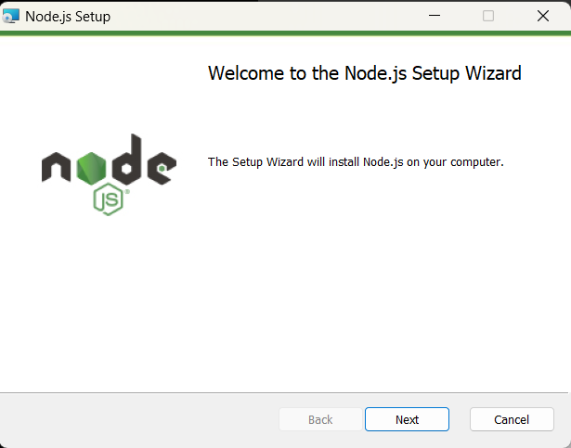
2. Make sure the npm and node.js is under the Add to PATH icon.:

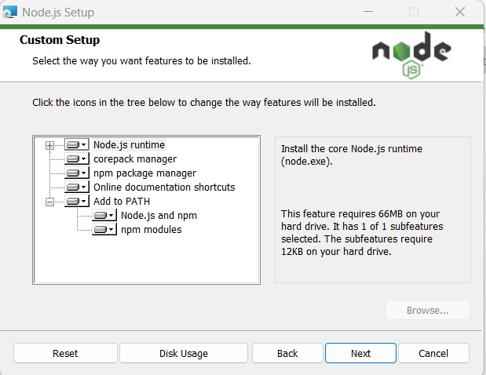

1. Click install

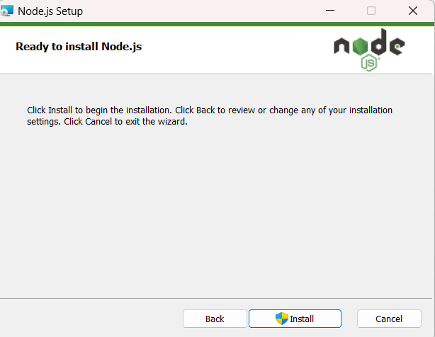

1. This will appear.

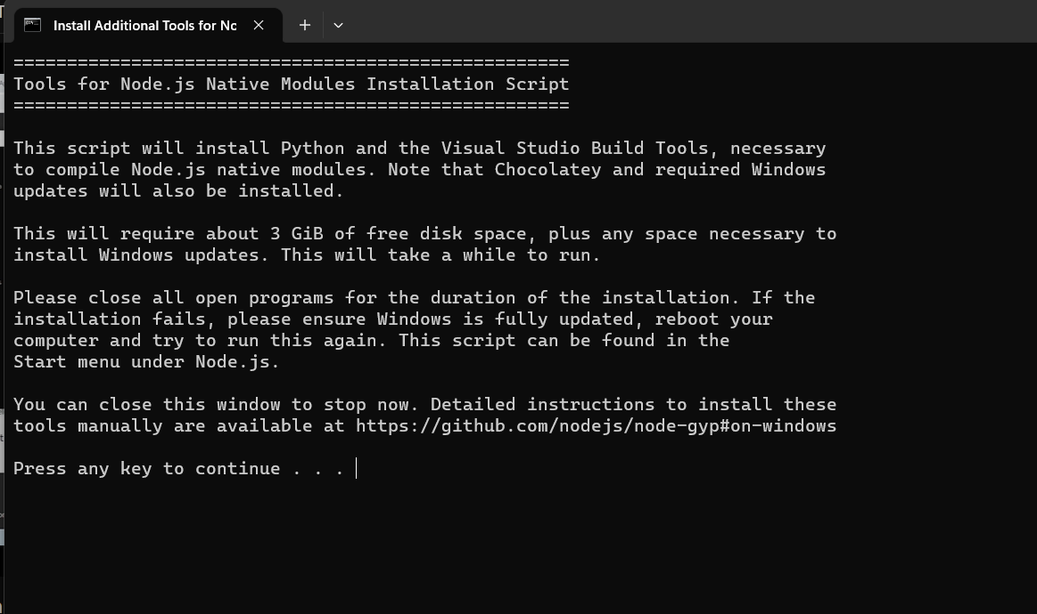

1. Check if it is successfully installed in Command Prompt.

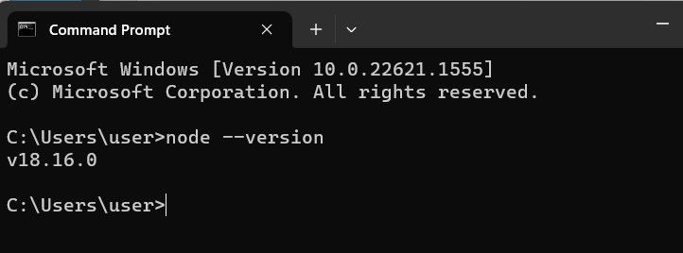

1. Install GIT at git-scm.com
2. Install Cordova

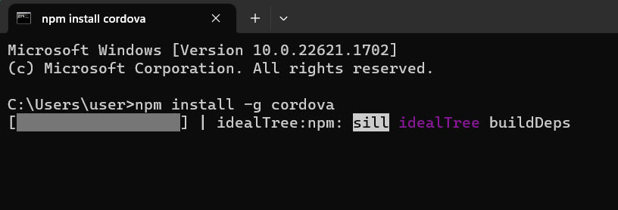

-g mean to install it globally.

1. Cordova is successfully installed.  
   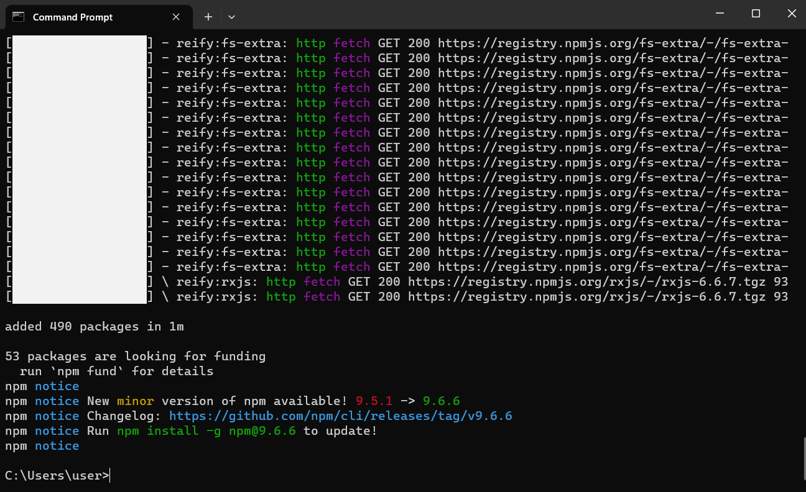

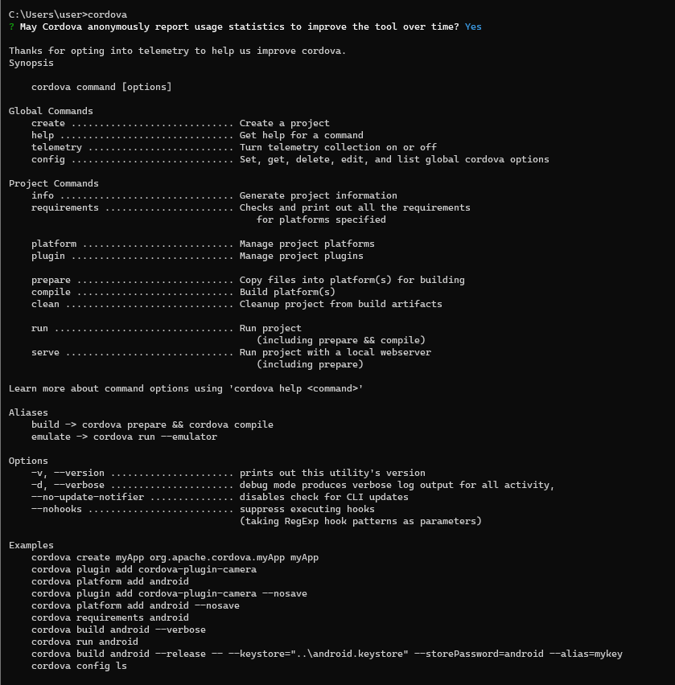

This is the cordova version that I’ve installed:

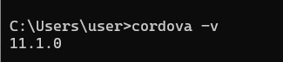

1. Create/ setting the environment in the Local Disk C named “development”
2. Try creating a new project inside the development file named “demo” .  
   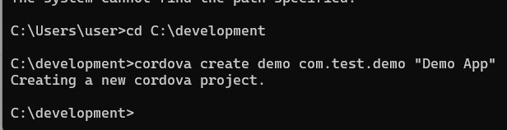  
   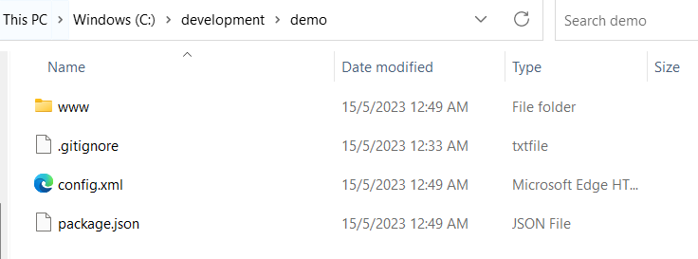
3. Tell the cordova to create an app which the platform is Android by typing ‘cordova platform add android’.

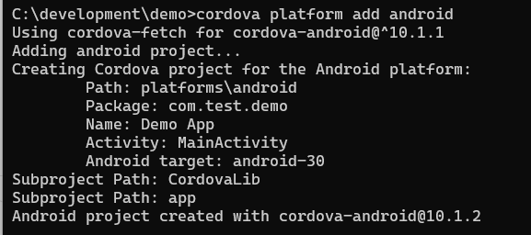

After that, it will create another files such as:-

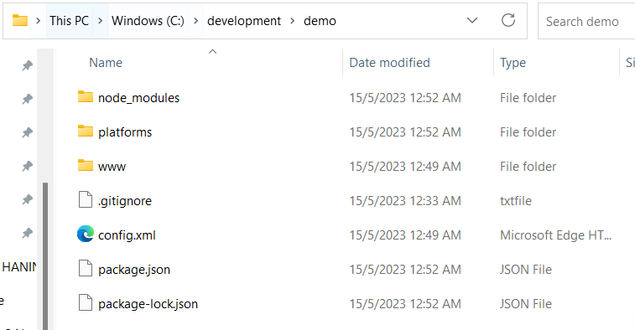

And in the platform folder there will be android folder.

1. Install Java Development Kit(JDK) version 11.0.19 to the computer.

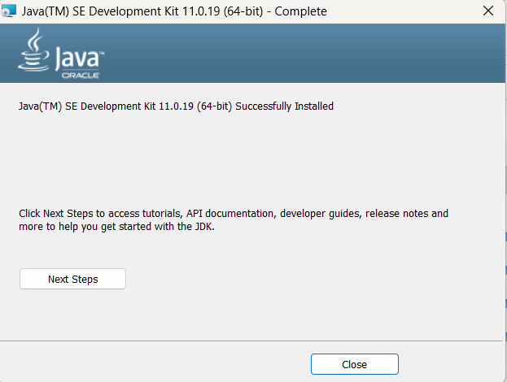

1. Do some setting for the JDK.

Add JAVA_HOME and the java file for the value at System variables.  
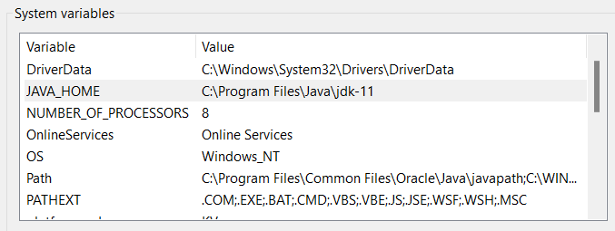

Then, add %JAVA_HOME% and %JAVA_HOME% \bin in the Path for the User variables for User.  
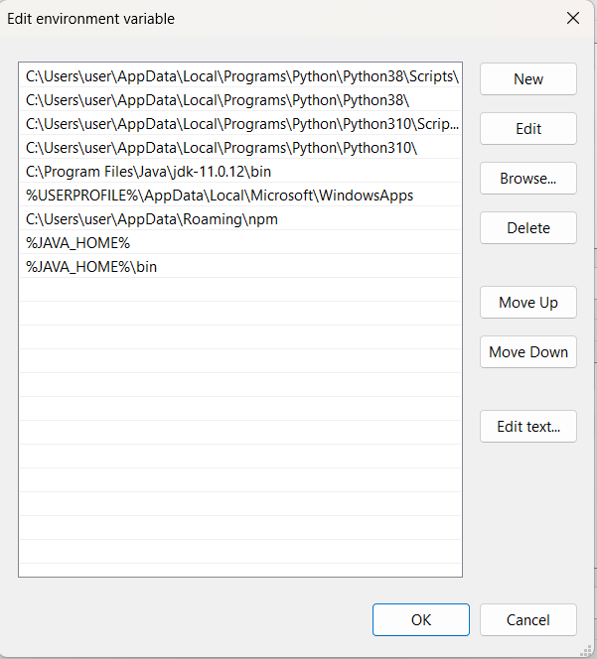

1. Install Gradle  
   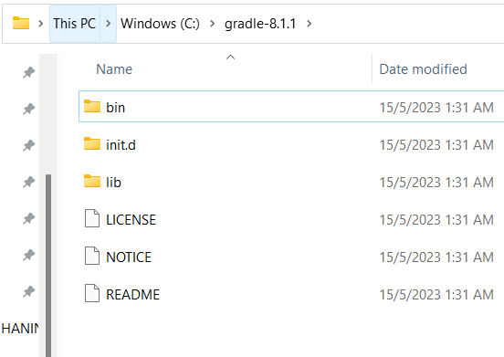

Next, setup the setting for the Gradle.  
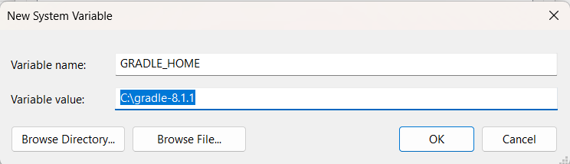  
  
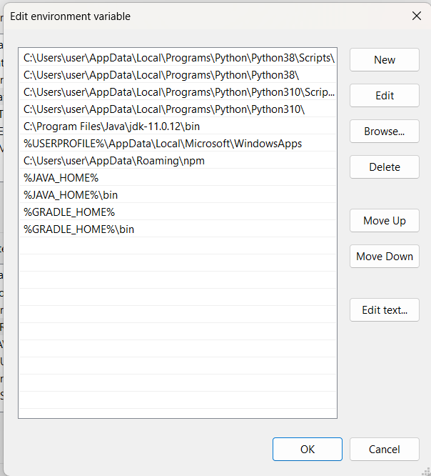

1. Download Apache ANT and put it inside the development file.  
   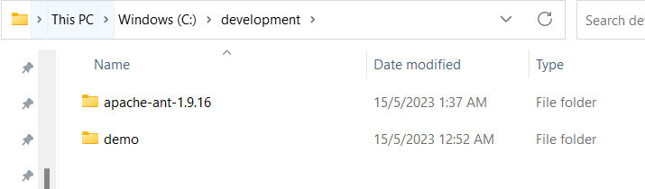  
     
   Next, setup the environment variable as usual.
2. Install the Android SDK or Android Studio  
   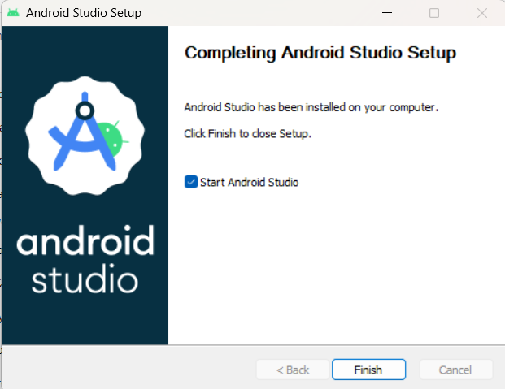

SDK Folder : C:\Users\user\AppData\Local\Android\Sdk  
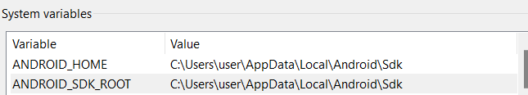

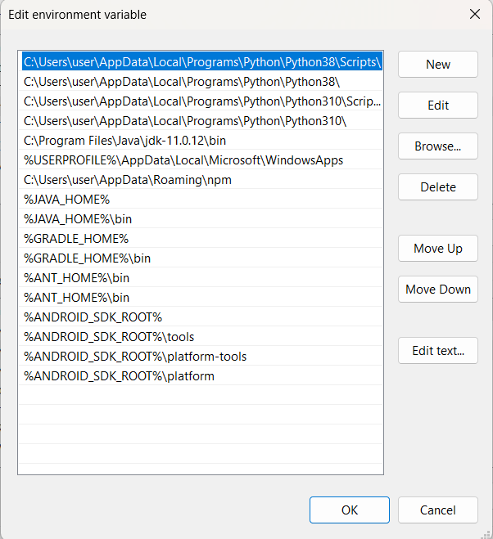

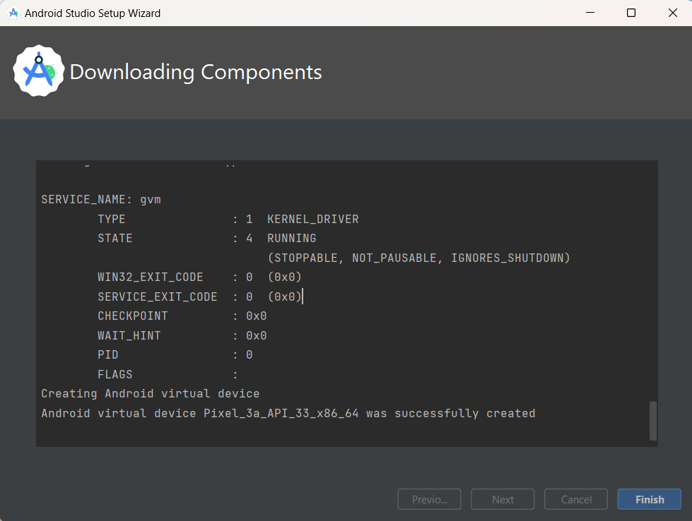

1. Install Emulator  
   Nox Player is installed.  
   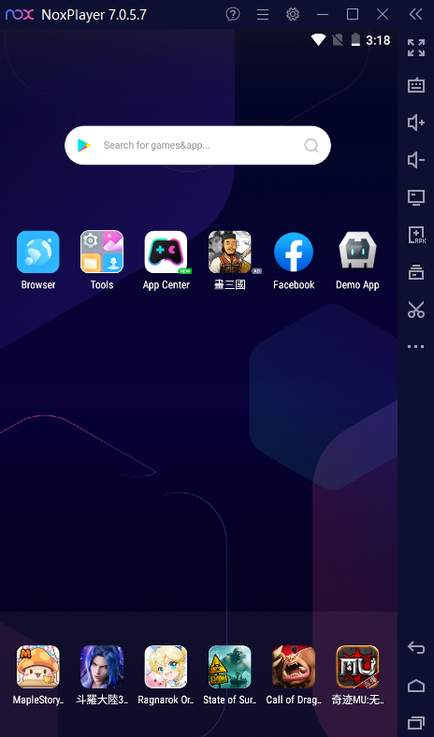

Task 2

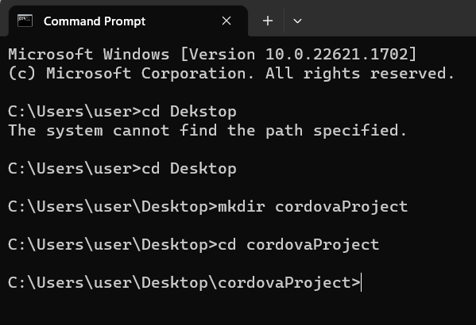

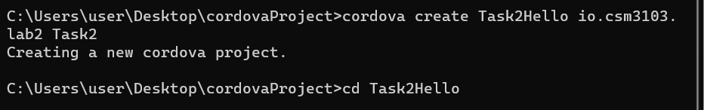

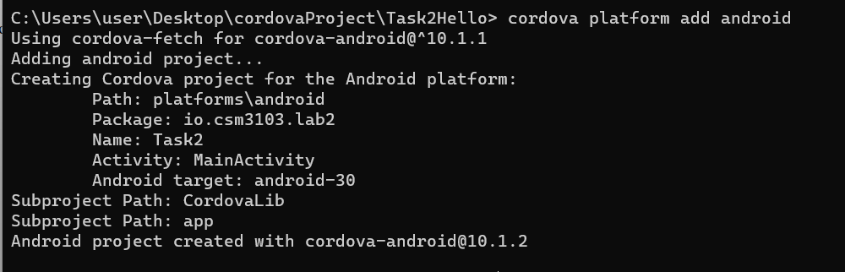

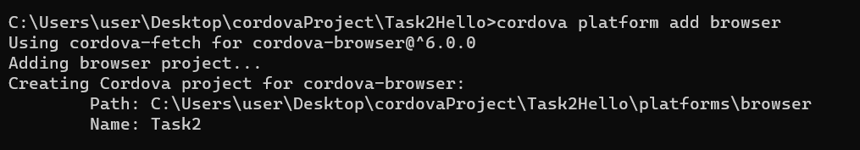

Cordova run browser :-

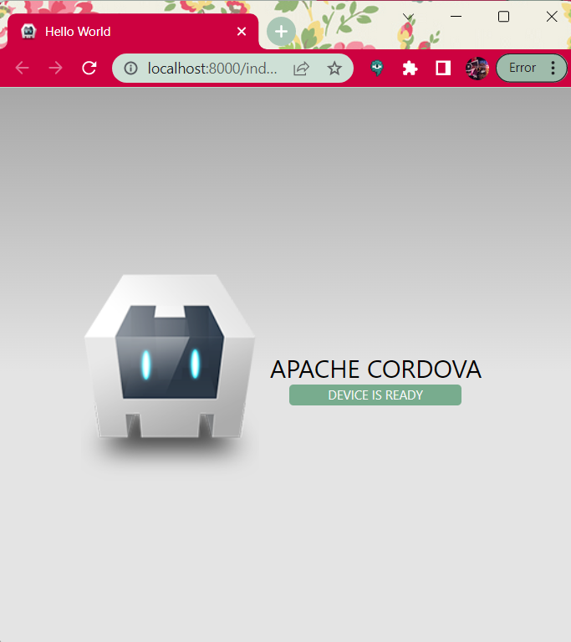

First cordova project on android

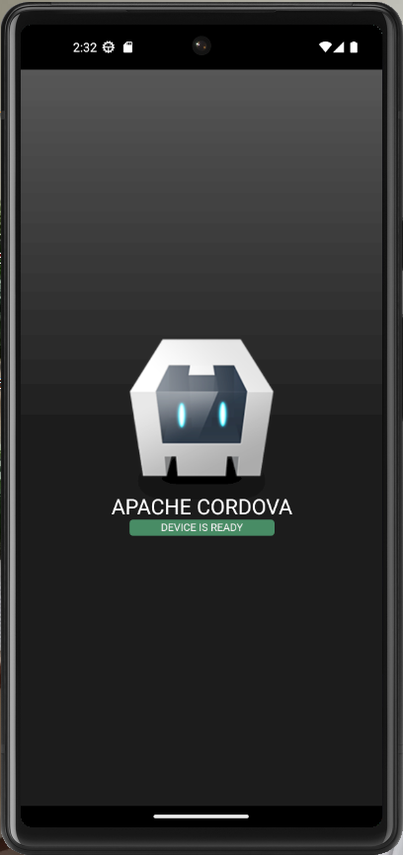

Task 3

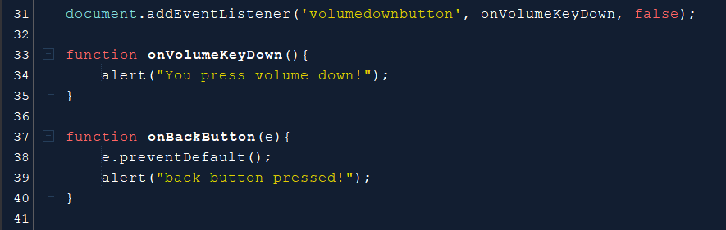

4.

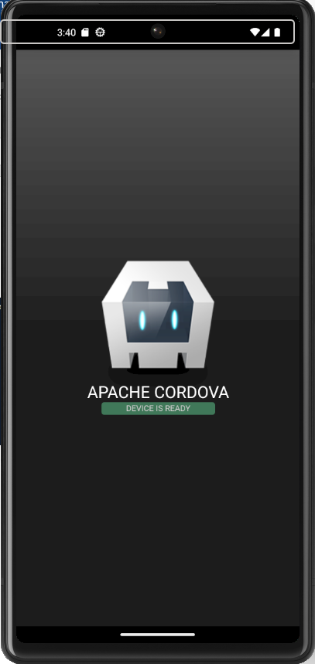

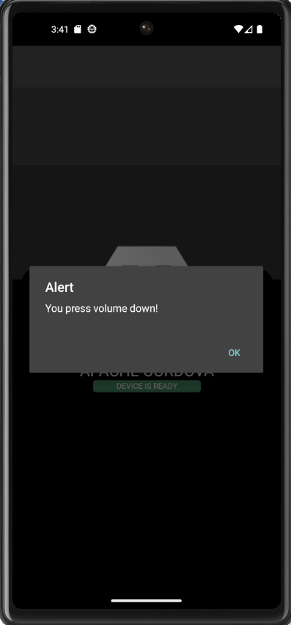

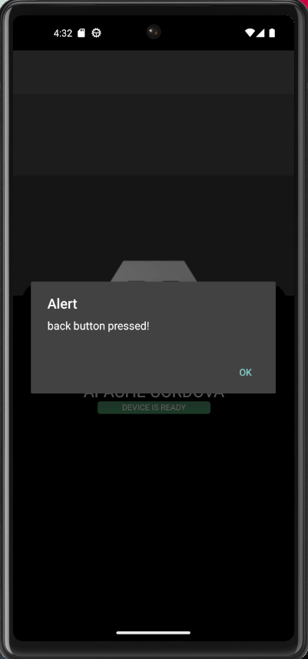

7. What is the purpose of e.preventDefault() ?

The preventDefault() method cancels the event if it is cancelable, meaning that the default action that belongs to the event will not occur. For example, this can be useful when: Clicking on a "Submit" button, prevent it from submitting a form. Clicking on a link, prevent the link from following the URL.

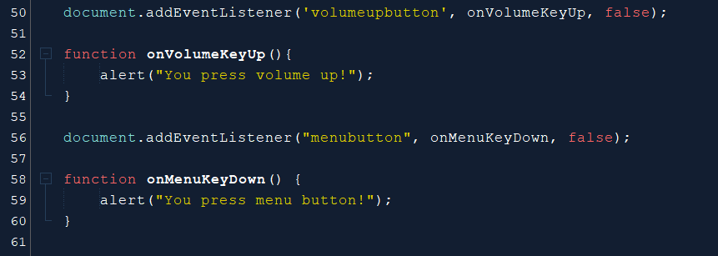

Task 4

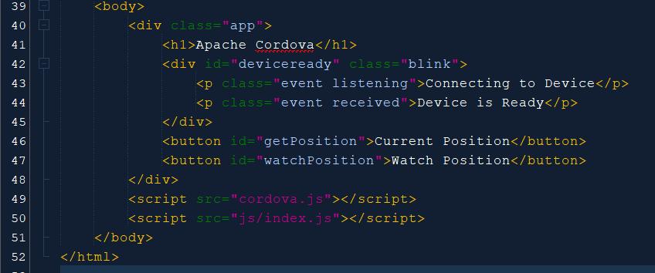

3. Add the given code on line 46 and 46 to index.html

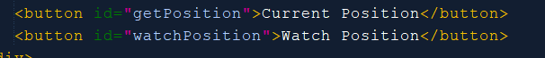

4. Open index.js and add the following code inside the ready function

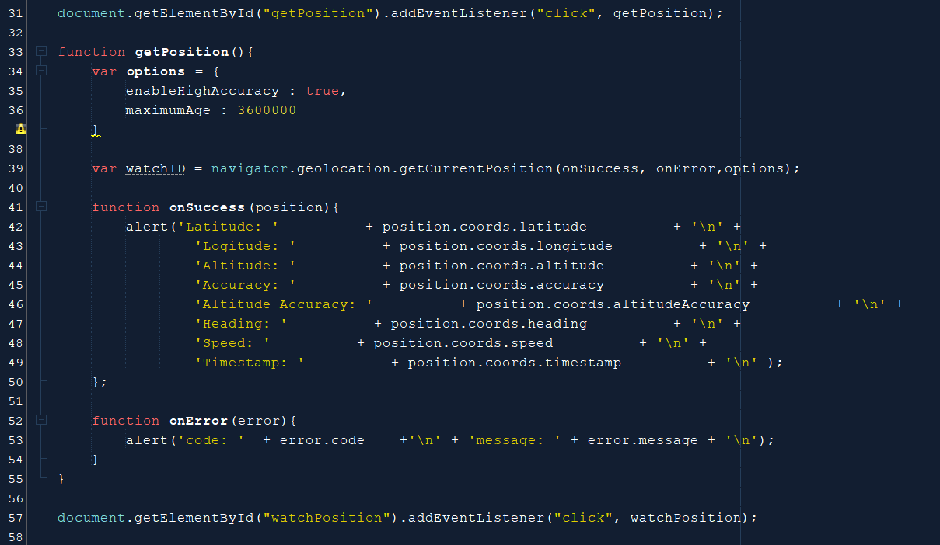

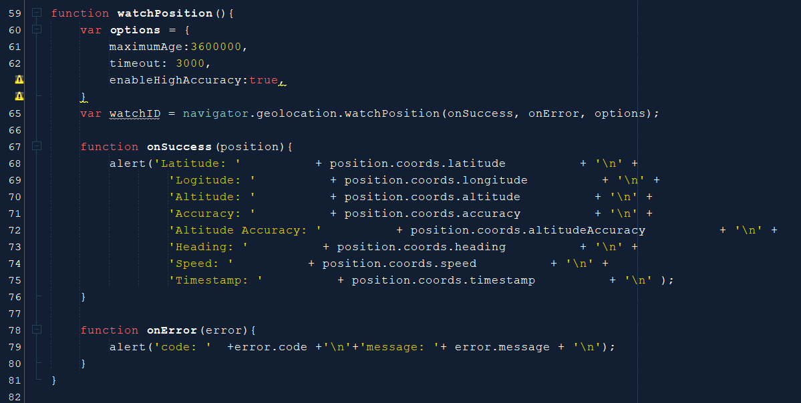

6. Enable developer mode.

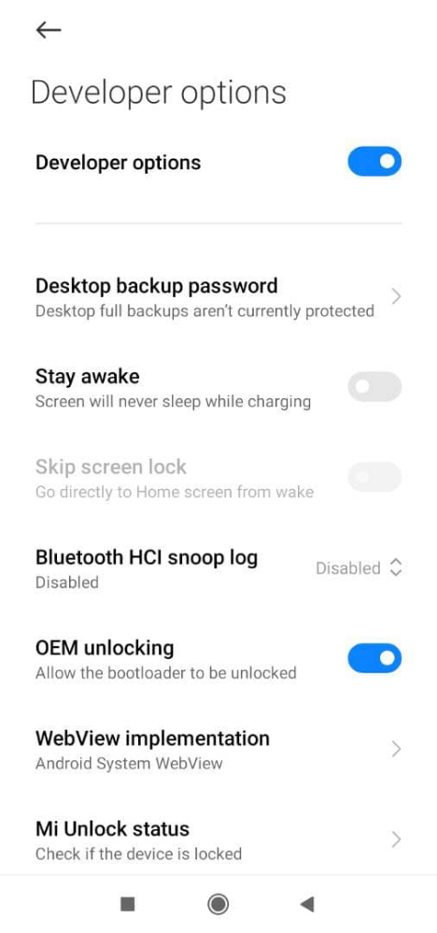

10. Run cordova

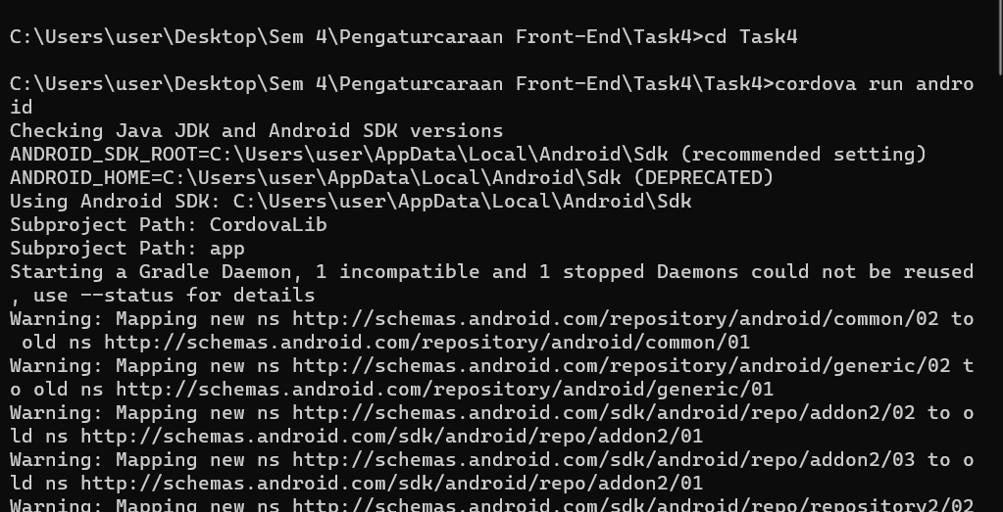

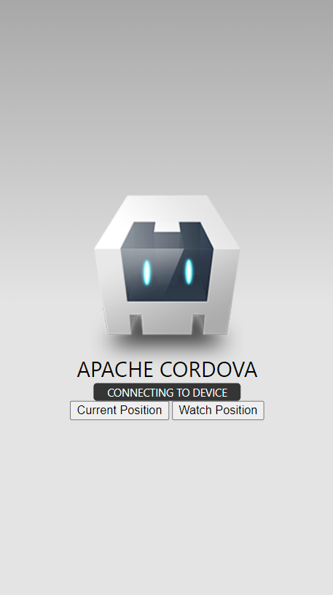

Link GitHub for the lab : <https://github.com/ilhamhanina/Code-Lab-CSM3103-S63762.git>